Haiti EMR System Requirements Document
Wayne State University
CSC 4996/4997 Fall 2012
1. Introduction
The Republic of Haiti is located on the western part of the Caribbean island of Hispaniola. In January 2010, this small nation experienced a violent magnitude-7.0 earthquake that displaced millions of people throughout the country and damaged an already struggling and insufficient infrastructure. Among the problems faced by Haiti, especially in the wake of the earthquake, is adequate access to medical care for its citizens. According to the World Health Organization before the 2010 earthquake, 46% of Haitians did not have access to health care because they either lacked the funds or access to facilities, 43% lack recommended immunization. Since more than 80% of Haitians live below the poverty line, malnutrition is also a major issue. These factors contribute to a life expectancy of only 44 years.
Because of this lack of access to affordable health care, many organizations travel to Haiti each year to set up free clinics. Unfortunately, many of these clinics document their patient’s visits with only paper forms that are not archived or maintained. This provides many problems for the clinicians: Uncertainty about previous treatment, trends in patient health may go unnoticed, among others. Due to a general lack of infrastructure in many regions of the country, however, traditional Electronic Medical Record (EMR) systems do not provide the needed functionality. In many regions, especially rural, people see physicians only once or twice per year travelling with teams that set up transient clinics. Such clinics are set up for high volumes in order to reach a large number of people in a very short amount of time. In such clinics, medical care is delivered in a high intensity fashion in a chaotic environment. For this reason, these clinics must have a dynamic organization to respond to moment-by-moment situational change, that are often-times unexpected, in order to maintain the fast-pace of delivery and reach the team's goal for the mission.
The Wayne State University Computer Science Department has been contacted by one of these teams. The specific request is to assist them in the creation of an EMR system that is tailored to such a temporary clinic. This new system will help them deal with the unique issues related to the administration of a clinic in a low-to-no infrastructure situation. The potential benefits are many-fold: tracking patient encounters from year to year, improving planning for future medical missions, and improving understanding of the patient population through long-term data collection. Our task is to deliver such a system and contribute to the health of those in need through technology.

1.2 Definitions, Initialisms and Acronyms

Chief Complaint - The reason why the patient is in the clinic, stated subjectively by the patient.
Clinic - The area designated to see patients. This may include tents, empty buildings, a residence, or even an open area of land. The EMR is in the 'clinic' only during use, and will be otherwise stored safely in the nearby guesthouse.
Consistency - Unification of the medical database across all terminals.
Electronic System - The system running the EMR as a whole; including all necessary hardware and software.
EMR - Electronic Medical Record
Encounter - data associated with a specific meeting between a patient and physician regarding a single chief complaint.
Infrastructure - the composite systems, mechanical and otherwise, that support the function of and include the electronic system; this includes generators, storage facilities, etc.
Inventory - the running list of clinic supplies; i.e. medications.
Medical Record – All medically relevant data associated with one patient, including all previous encounters.
Lesion - A departure from normal structure.
Medical Personnel - Anyone involved directly in the care and treatment of patients.
Medical Database - collection of medically relevant information about a population of patients.
Paper System - Paper forms coordinating medical record data in parallel with electronic system.
Patient - A person visiting the clinic to seek any level of medical care.
Pharmacy - The area designated by the medical team to distribute supplies to patients.
Synchronization - unification of encounter-specific information between terminals.
Team - the collection of medical personnel and volunteers participating in the clinic.
Terminal - laptop computer unit of the electronic system running a version of the EMR software.
Treatment - any medical intervention or supplies provided to a patient; e.g. medications, splint.
Vitals - The primary physiological signs relaying information about health; e.g. blood pressure
Volunteer - Anyone assisting in the clinic in a role that does not directly involve patient care.

1.3 Purpose
The purpose of this document is to introduce and convey the minimum requirements of the Haiti EMR System to the student developers enrolled in Wayne State University’s computer science senior project class (CSC 4996/4997).

1.4 Scope
This project will produce an electronic system suitable for EMR in low-to-no infrastructure clinics. The system will assist clinicians with the administration of all aspects of the clinic (which are described later). Because of the possibility of complete infrastructure failure (i.e., loss of power for an extended period of time) a paper system that allows for later entry into the electronic system must be available.

2. System Description
This section will describe the existing clinic plan and provide a list of the minimum functional and non-functional requirements for the Haiti EMR Electronic System. Please note that these are the minimum set of requirements for the project to be considered successful. The student project groups will need to communicate with the client to produce more detailed lists.

2.1 Existing System
The group that has contacted us about the EMR electronic system regularly operates a free clinic in Pointe-â-Raquette, île de La Gonâve, Haïti. The diagram below represents one setup for a temporary clinic that has been used in the commune of Pointe-â-Raquette. A description of the clinic activities, as provided by one of the clinicians, follows.
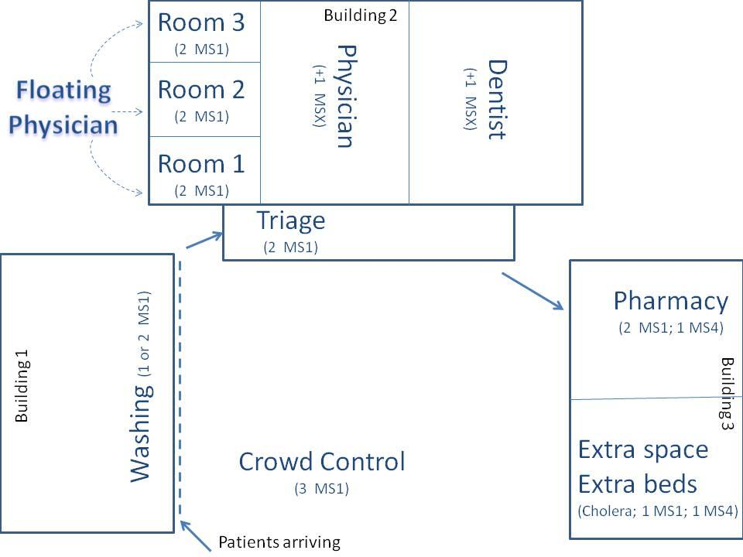

The three buildings depicted are normally used as a school, a permanent (though poorly stocked and nearly unstaffed) clinic and storage facility. The town's Catholic priest owns and runs these buildings. (Note: MS stands for 'medical students' and the following number [1-4] indicates level of training).
As can be seen, a typical team consists of about 20 members; often there are local Haitians that are hired to help out with necessary tasks such as crowd control and translation between Haitian Creole, the predominant native language (the second being French), and English. These are the different 'jobs' broken down with a little bit of detail in the order in which they are encountered by a patient.

- Crowd Control: A few team members will maintain some semblance of order among the crowd of patients that develops. Rarely is the peace broken by any dispute but it keeps things 'sane' when people can be coaxed into lines (queues). Crowd Control includes playing with children and generally keeping them occupied.
- Washing: This is somewhat unique to our teams. It's nice to put a hand on people and wash them. It also gives everyone the sense that they received some kind of care. It's also medically useful for two reasons: 1) any lesions or wounds will benefit from a cleaning, not to mention that it will be better prepped for a physician's viewing and 2) a patient who doesn't wash well under normal circumstances may benefit from being washed in terms of learning how to wash.
- Triage: This is a complex and sometimes stressful job. This is the stage where vitals and basic patient information. This is written down on a form - the paper system. Even with the new electronic system in place, we propose to still employ the paper system due to the hectic nature of this position. Patients are then given the form and instructed to present it to the physician team that they are assigned to; less urgent patients are assigned to the student-doctor teams (left end of building 2) who share one 'floating' physician (if available) while more urgent patients are sent to the licensed physician (center of building two). Pure dental cases are sent directly to the dentist, if available. Triage also coordinates a 'waiting area' when the physician teams become backed-up.
- Physician teams: Each team always consists of two members; a student doctor and a student doctor, a licensed physician and a student doctor, a registered nurse and a student doctor, etc. depending on the make-up of the group. For less urgent patients, these encounters can last just a few minutes, with the aim of moving on to see the next patient (so the electronic system must be quick and easy to use). For the more urgent patients, these encounters can last many minutes up to a couple of hours (so the electronic system must still retain some ability to enter somewhat more complex data when necessary). The environment is hot and electricity is inconsistent - infrastructure problems occur frequently.
- Pharmacy: This is where the patients get any medication or other items (sometimes prescription glasses are available, etc.) that are prescribed by the medical teams. Surprisingly to some, this is also a hectic station due to the need to give patients the treatments they need but to also be sparing with an often very limited inventory. Many times, the exact medication prescribed by the physicians is not available and a substitute is made. [Note: you may notice a potential disconnect here for the EMR. If the medical team prescribes a medication and records it into the system, the pharmacy might provide something slightly different or nothing at all. In this instance, the electronic system might record that a patient received a treatment when they did not! - Synchronization is needed.]

2.2 Functional Requirements
The following is a list of functional requirements
- Allow for the entry, modification and viewing of individual medical records.
  - Medical records include demographic information about a patient, treatment history and physician/clinician notes.
- Allow for the entry, modification and viewing of an encounter with an individual.
  - An encounter should track all interactions between a patient and anyone working in the clinic for a given visit/chief complaint.
  - Encounters should be accessible from the patient’s medical record.
- The system must be able to use paper forms for data entry - the paper system
- Provide synchronization of medical databases across multiple un-networked terminals
  - Consistency should be maintained within 1 (one) day.
  - Synchronization may depend on user actions (such as carrying a USB memory stick among the terminals.)
- Provide an image of the individual patient associated with any medical record being modified to assist with the positive identification of patients.
- Provide the ability to search medical records and the medical database.
  - Search the entire contents of all records - the medical database
  - Search only in selected fields
  - Constrain searches by date or other relevant field(s) (e.g., diagnosis, medication, etc.)
- Track pharmaceutical distribution and inventory.
- Provide the ability to synchronize medical records over the internet or other network in a secure way, when possible.
- Provide the ability to quickly and easily attach files (i.e., photographs, additional medical records, etc.) to medical records and encounter records.
- Provide a mechanism for exporting user records in a common format (i.e., PDF, JPG, etc.)

2.3 Non-functional Requirements
The Haiti EMR Electronic System must satisfy the following non-functional requirements in the categories of Security, Documentation, Performance and Reliability.

2.3.1 Security Non-functional Requirements
- All relevant privacy laws must be observed.
  - The laws outlined by HIPPA apply, as it does to all clinical situations in the United States. If Americans violate HIPPA, even in a foreign country, they can be tried.
  - As a general guideline, ensure that all patients' data can be treated in a fashion not unlike the way it is treated in the United States. Patient privacy is key!
  - Under the HIPAA regulation (45 CFR 164.514), de-identification requires removal of several identifiers, including but not limited to names, dates of birth, and full-face photographic images and any comparable images. Only relevant team personnel (medical personnel only) should be able to access this sensitive, highly personal data; even when the patients are not American and the data was collected in a foreign country.
  - When a search is being done on the medical database, de-identification should be employed always. Indentifying patient information should only be displayed during an active encounter.
- Access to the Haiti EMR Electronic System's medical database should be restricted to those persons who have a need to use it.
- Medical Records must not be transmitted “in the clear” across any network.
- Stored medical records should not be easily accessible from outside the system or should be suitably encrypted/de-identified.
2.3.2 Documentation Requirements
- All functionality implemented in the Haiti EMR Electronic System must be documented. (i.e., The user input and expected output should be defined.)
- All fields must have some meta data associated with them giving precise descriptions and examples of the data they should contain.
2.3.3 Performance Requirements
- Each user of the system should interact primarily with a single screen to perform their task to minimize the number of clicks and therefore the amount of time interacting with the electronic system during an encounter.
- Storage of a new encounter should occur and provide positive feedback within 1 (one) second.
- Retrieval of medical records should occur within a reasonable time, to be determined by the client.

2.3.4 Reliability
- The synchronization functional requirement allows for distributed backups of the medical records/database.
- When synchronizing the medical database, users must be able to manually identify which medical database takes precedence.
- Consistency of medical records split across multiple terminals should be assured at synchronization.
- Irreconcilable records should be identified for manual intervention.
- A Paper System, as a backup, must be provided for all data entry in the case that all infrastructure is lost.
- The system shall operate on a stable operating system as reboots over the course of an encounter or between successive are unacceptable.
- A physical workflow ensuring that all terminals are synchronized must be provided.

